On the **Friday, 19th May 2017**, after school, I went to **La Turballe**, the place Rotary had planned us to go. I had waited so long for it ! We went there by car with the two exchange students of my Rotary club and stopped at **Guérande** where we ate an ice cream, because we were early. We also went for a walk hehe.

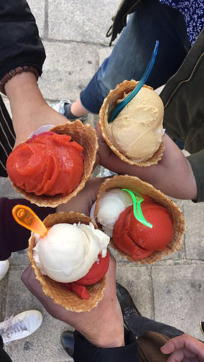

We then arrived at the place we were staying for the weekend. Some people were already there but most of the students arrived later by bus. We made bedrooms of six people, I made new friends and there was a real good atmosphere, that was really cool !

During the evening, we didn’t do much, we had time to talk and exchange together and introduce each other. That was **the best evening** so far !

When the night fell down, dozen of people came with us to listen my friend **Lucie** play the guitar. We were sitting in a disorganized circle, everyone were talking together (in french, english,.. We could even reach to hear a bit of chinese, japanese and korean : team Asia !) That was a nice and chill atmosphere, you know that kind of moment you’re sitting on the cold floor but you just don’t care because you’re with your friends, happy as you are, just talking about everything. Yeah, **that** kind of thing. We also sang together, even tho I am so bad at remembering the lyrics.

Then, we went back in our rooms and played some cards game, that’s the best way to end a nice evening !

The next morning we woke up early because the breakfast was at 8. It was raining so we thought it would be bad day. BUT it ended up being sunny in the afternoon. So, the morning we had the presentation of the **Rotary Youth Exchange rules**, the **4D** :

-No Drugs

-No Drink(drunk)

-No Drive

-No Date

 After this, we made groups with people from the continent we are going to ( I went with asian and other students going to **Asia**). This year, in my district, there are three students going to **Taiwan**, One in **Indonesia**, One in **Thailand** and then there’s me, going to **Korea** !

Later in the afternoon, we went to the beach but I didn’t swam or anything , that was wayyy too cold ! We went for a walk, it was really nice ‘cause Rotary let us go wherever we wanted, we didn’t have to stay near them.

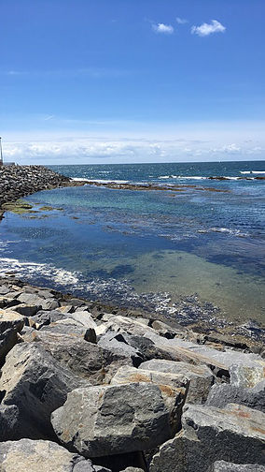

 We went back to our rooms to prepare the **talent night show**. Since I don’t have any particular talent, I didn’t really do it ^^’

But I knew that the others would be able to **share** with us their **culture** through the **music**, **dance**… And I wasn’t wrong ! After the talent show we went outside to talk, laugh and play basketball. I **really** liked it ! We went to bed earlier than the night before tho.

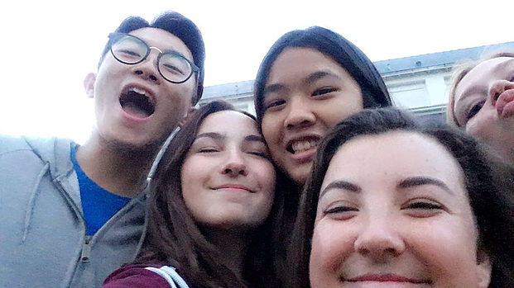

 On the last day, **Sunday, 21st May 2017**, we could sleep in (though I didn’t do it because I like waking up early hehe). I was kinda sad when I realized it was the last day : it was way too **short** !

But I quickly forgot about it as I was informed that we would get our **Rotary blazer** in the afternoon. Parents arrived, welcomed by Rotarian. Then, we went to eat lunch and soon after the « **ceremony of blazers** » started. Haa, I had waited for it for son long now ! They called out, name after name, **each Outbound**. I was the last one in Asian continent to get it. We also had a french flag, some pins, a shirt with Rotary logo and so many « exchange students cards » (the ones we give when we meet someone from Rotary). I have a **terrible** face on the picture btw. It was a very touching moment. After this, we made (how should I call this) a **photoshoot** and we were so proud to show our beautiful **blue jacket**. We even exchanged pins! I already got quite many actually haha (THIS IS JUST THE BEGINNING)

Symbolically, I let to korean student of my district put the very first pins on my jacket. This pins was the one Rotary had created for the 2017-2018 promo ! ***« Rotary : make a difference »***

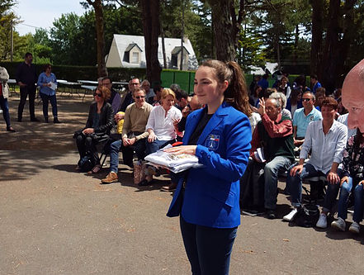

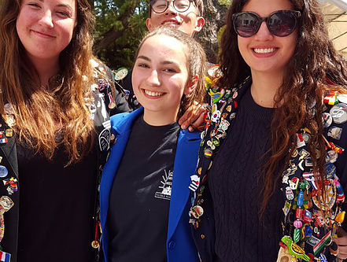

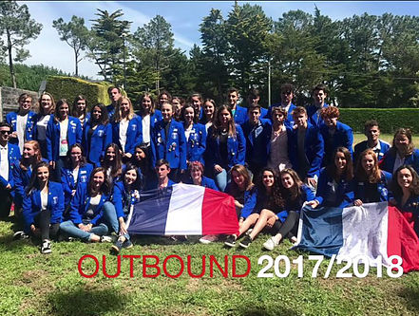

 In conlusion, it was a weekend full of **new meetings, new feelings** : the **excitment** of leaving even stronger, **sadness** of saying goodbye to those who end their exchange, or **dreams** that continue even after. That was **magic**. Of course, not perfect, but that’s what made this weekend so **special**. I will remember it. I discovered so much about differents countries in the world, I’m leaving with my eyes full of stars !